Promotional Strategy for an Ecotourism Business in Kiudkad, Siruma, Camarines Sur

Frances D. Sara ¹
1 – Siruma National High School

Publication Date: August 23, 2025 | DOI: 10.5281/zenodo.16948793
Abstract

This study aimed to develop a targeted promotional strategy to increase tourist visitation at KiudKad – “The Last Resort,” an off-grid eco-tourism destination located in Siruma, Camarines Sur. Guided by the Destination Image Formation Theory, Push-Pull Theory, and the 7Ps of Marketing, the research employed a descriptive-exploratory qualitative design. Data were gathered through a case study approach, including unstructured interviews with management and employee surveys. A comprehensive SWOT and TOWS analysis was conducted to identify internal strengths and weaknesses, as well as external opportunities and threats.

Keywords: Ecotourism, Promotional Strategy, Sustainable Tourism, Destination, Marketing, KiudKad, SWOT-TOWS Analysis, Push-Pull Theory, 7Ps of Marketing.

INTRODUCTION
The growing global tourism industry stands as a significant driver of economic growth, cultural exchange, and regional development for numerous nations worldwide (United Nations World Tourism Organization, 2023). For countries rich in natural resources and cultural heritage, tourism, when responsibly managed to foster job creation, social integration, heritage protection, and sustainable livelihoods, presents a vital pathway towards sustainable economic resilience and local livelihood opportunities (United Nations World Tourism Organization, 2025). In relation, the Philippines, an archipelago recognized for its rich biodiversity and varied landscapes, strategically acknowledges the significant potential of its tourism sector as a key contributor to national economic development and a driver for local economic empowerment. This recognition is evidenced by initiatives focusing on enhanced air connectivity, infrastructure development, and the promotion of emerging destinations to decentralize tourism & economic benefits across diverse communities (Rosel, 2025). Within the Philippine context, regions blessed with unique geographical features and ecological richness often hold untapped potential for tourism development. The Bicol Region, situated in southeastern Luzon, exemplifies this with its tapestry of volcanic peaks like Mayon and Bulusan, pristine coastlines and beaches, and verdant landscapes, making it a prime ecotourism destination with diverse attractions from mountains and caves to beaches and coral reefs (Philippine Department Development).
The Bicol Region, situated in southeastern Luzon, exemplifies this with its tapestry of volcanic peaks like Mayon and Bulusan, pristine coastlines and beaches, and verdant landscapes, making it a prime ecotourism destination with diverse attractions from mountains and caves to beaches and coral reefs (Philippine Department of Tourism, 2024). The province of Camarines Sur, a key component of the Bicol Region, is endowed with a diverse topography that ranges from fertile agricultural lands to rugged mountain ranges and an extensive coastline dotted with picturesque islands and beaches (Visit CamSur, 2025). This inherent natural capital positions Camarines Sur as an attractive destination for both domestic and international tourists seeking authentic and immersive experiences.
In relation, the coastal municipality of Siruma in Camarines Sur has strong potential for nature-based and ecotourism. With its diverse topography of upland and hilly areas (GOV.PH, 2023), Siruma offers rich biodiversity and scenic landscapes. Its combination of land and coastal features provides a unique setting for both relaxing beach visits and adventurous inland activities.
On one hand, anecdotal evidence and initial observations suggest the inherent beauty of Siruma's natural environment. A travel blog post by Banaria D. (2022) deeply highlights the town's "immeasurable deep breathing sensation" stemming from its verdant green scenery, alongside captivating scenic sights such as its pristine white and beige sand beaches, serene and untouched islands, the inviting aquamarine ocean, and panoramic mountain top views. This narrative highlights the potential for Siruma to offer a deeply restorative and aesthetically pleasing experience for visitors seeking rest from urban environments and immersion in natural beauty. Vivid descriptions of deep breathing and the beauty of the beaches and ocean show that the place can create strong positive emotions in tourists.
However, despite these inherent natural advantages and the positive sentiments expressed by some visitors, Siruma currently lags behind other leading tourist destinations in the Philippines, requiring significant and concerted effort to achieve major recognition both nationally and globally (Banaria D., 2022). This gap between its potential and its current standing highlights a critical need for strategic interventions aimed at enhancing its visibility, improving its tourism infrastructure, and effectively marketing its unique attractions. The lack of widespread recognition may stem from various factors including limited accessibility, insufficient marketing efforts, underdeveloped tourism facilities, or a combination thereof. Addressing these limitations is crucial to unlocking Siruma's full tourism potential and ensuring its sustainable growth as a desirable destination.
Recognizing this gap and aiming to capitalize on its inherent potential, the Local Government of Siruma has explicitly stated its mission to promote investment opportunities and enhance the local tourism industry (GOV.PH, 2023). This proactive stance by the local authorities underscores a commitment to leveraging Siruma's natural assets for economic development and community benefit. Their focus on promoting investment suggests an understanding of the need for both financial resources and strategic partnerships to develop the necessary infrastructure and services to support a thriving tourism sector. This study aligns with the local government's objectives by focusing on a specific tourism establishment within Siruma and aiming to contribute to the broader tourism goals of the municipality.
This study focuses on Kiudkad, a resort located in Barangay San Ramon, Siruma, which was locally known as "the last resort" (Tan, K.S., 2022). By concentrating on a specific resort, this research aims to provide a micro-level analysis that can offer practical and targeted recommendations for enhancing its appeal and operational efficiency, ultimately contributing to the overall attractiveness of Siruma as a tourist destination. KiudKAd distinguishes itself by offering a diverse range of accommodations, each designed to cater to varying group sizes and preferences. All available houses, including Blakhaws, Brownhaus, Kamarin, and Kiudkad Lodge, were thoughtfully equipped with essential amenities such as a full kitchen, running water, a toilet, fans, solar power, and reliable WiFi connectivity. The pricing and capacity vary across the different units; for instance, the Kamarin was the most spacious, accommodating up to 12 people, while the Kiudkad Lodge was better suited for smaller groups of 6. This flexibility in housing options, coupled with consistent essential amenities, allows guests to select an accommodation that best fits their specific needs and budget, providing a comprehensive and comfortable experience at KiudKAd (KiudKad - The Last Resort, 2024).
Kiudkad, while offering a seemingly paradisiacal experience where a cliffside overlooks rolling hills gently covered in cogon grass (Tan, K.S., 2022), faces significant infrastructural challenges that could impede its growth and the overall tourism experience in the area. Access to the resort involves a considerable journey, including a substantial 71 kilometers of paved road from Naga City followed by a challenging seven-kilometer muddy trail (Tan, K.S., 2022). This accessibility issue presents a significant barrier for many potential tourists, particularly those seeking convenience and ease of travel. The difficult terrain not only increases travel time and costs but also raises concerns about safety and comfort.
Despite these hurdles, KiudKad - The Last Resort, nestled in the remote fishing community of Siruma, Camarines Sur, employs a distinctive blend of promotional strategies that highlight its identity as an exclusive, off-grid, and deeply immersive nature retreat. These strategies were meticulously crafted to attract a specific niche market: individuals seeking to disconnect from urban life and reconnect with nature in its rawest form, all while strictly adhering to a philosophy of exclusivity over high-volume tourist arrivals. A core strategy involves emphasizing exclusivity and seclusion; KiudKad operates strictly "by reservation only," a policy that fundamentally limits tourist numbers and fosters a peaceful, private atmosphere (KiudKad - The Last Resort, 2024). This approach was reinforced by the promise that booking a house grant "exclusive access to the whole property—a white-sand beach, numerous sunset and picnic spots and its surroundings" (KiudKad - The Last Resort, 2024).
This commitment to exclusivity means that the resort does not aim for high average tourist arrivals; their business model inherently dictates a lower guest count, prioritizing a high-quality, private, and sustainable experience over maximizing visitor volume. For instance, their accommodation options were limited to four houses and two campsites, with capacities ranging from 6 to 12 people per house and 10 per campsite, and the provision of exclusive property access per booking (KiudKad - The Last Resort, 2024). This limited capacity and "reservation only" policy were direct manifestations of their strategy to maintain an exclusive atmosphere rather than attracting a large volume of tourists. Furthermore, KiudKad's promotions heavily focus on an authentic "off-grid" nature experience. The resort proudly advertises its solar-powered facilities and encourages guests to embrace the "quiet, raw, and unapologetic" natural surroundings (Rappler, 2023). Promotional content frequently showcases nature-based activities such as trekking, free-diving, snorkeling, and kayaking, aligning the resort with environmental consciousness and outdoor adventure (KiudKad - The Last Resort, 2024; Rappler, 2023). The resort effectively utilizes a robust digital presence and content marketing to reach its audience, actively using social media platforms to share captivating visuals of their property and the unique experiences available (Destinations and Tea, 2023). They also benefit significantly from online listings and features in travel blogs and news articles, which detail their operational journey and unique offerings (Destinations and Tea, 2023; Rappler, 2023). A notable aspect of their promotional strategy was showcasing connectivity in a remote setting; recognizing the challenge of being in an isolated area, KiudKad highlights its reliable satellite internet connection. This directly addresses a common concern for travelers who desire an off-grid experience but still require some level of connectivity, transforming a potential drawback into a unique selling proposition (Panay News, 2023; SunStar, 2023).
Finally, KiudKad employs transparent communication regarding the "difficult journey" to the resort. They were upfront about the challenging 7-kilometer muddy trail leading to their location, advising visitors on appropriate transport (4x4 vehicles) and even offering shuttle services (KiudKad - The Last Resort, 2024). This transparency effectively manages guest expectations and attracts a clientele genuinely seeking an adventurous and unconventional destination, further contributing to the self-selection of their exclusive guest base.
This paper will outline a promotional strategy tailored specifically to Kiudkad, carefully considering both its unique natural assets and the existing infrastructural and environmental challenges. By thoroughly analyzing the current situation, this study aims to provide actionable and contextually relevant recommendations to enhance Kiudkad's visibility, improve its attractiveness to tourists, and contribute to the sustainable growth of ecotourism within the municipality of Siruma. The findings of this study were intended to be of practical value to the management of Kiudkad, the local tourism authorities in Siruma, and potentially other tourism stakeholders in similar developing destinations facing infrastructural and environmental considerations. The subsequent chapters will delve deeper into the existing literature on tourism promotion, analyze the specific context of Kiudkad and Siruma, and propose a comprehensive promotional strategy with concrete recommendations.

Research Objectives
This study aimed to develop a targeted promotional strategy to increase tourist visitation at KiudKad – “The Last Resort” of Siruma, Camarines Sur.

Theoretical Framework
This study's theoretical framework was built upon three foundational theories: Destination Image Formation Theory, Push-Pull Theory, and the 7Ps of Marketing. Together, these theories provide a robust and integrated lens through which to understand tourist perceptions and motivations, and to strategically devise an effective promotional strategy for KiudKad, a serene eco-friendly resort. Figure 1 allows for a deep analysis of how potential visitors form impressions, what drives their travel decisions, and how a tailored marketing mix can effectively engage them. The interplay between these theories will guide our understanding of how-to best shape KiudKad's appeal as a calm, eco-friendly escape, attracting visitors seeking tranquility and a connection with nature.

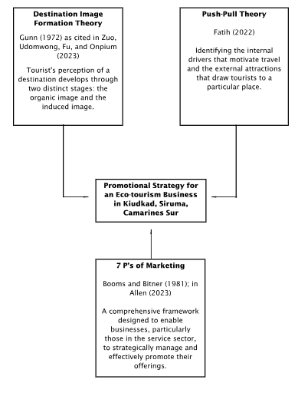
Figure 1. Theoretical Paradigm
Destination Image Formation Theory
Gunn (1972) Destination Image Formation Theory, as cited in Zuo, Udomwong, Fu, and Onpium (2023), posits that a tourist's perception of a destination develops through two distinct stages: the organic image and the induced image. The organic image refers to perceptions formed based on unsolicited information and pre-existing knowledge from non-commercial sources, such such as word-of-mouth, news reports, documentaries, or general cultural awareness. This natural formation of an image about a destination like KiudKad occurs without direct marketing influence.
The relevance of this theory to KiudKad's promotional strategy lies in its focus on the induced image. This image was deliberately shaped through planned marketing and promotional efforts, aiming to influence how potential tourists perceive the resort. For KiudKad, this means strategically highlighting its unique "pull" factors like pristine beaches, mountains, and immersive natural experiences. A consistent and targeted promotional approach across various media platforms—digital content, partnerships, and public relations—was crucial to present KiudKad as a calm, eco-friendly escape that resonates with travelers seeking relaxation and a retreat from urban life.

Push-Pull Theory
The Push-Pull Theory, as complemented by Fatih (2022), explains the psychological and motivational drivers behind travel decisions. According to this theory, "push" factors were internal desires that compel individuals to travel, such as the need to escape city stress, seek rejuvenation, or satisfy rising eco-awareness. Conversely, "pull" factors were the specific attributes or characteristics of a destination that attract tourists, as defined by Crompton (1977) and Dann (1977) (both cited in Fatih, 2022). These external allurements make one destination more appealing than another.
This theory was highly relevant as it guides the design of KiudKad's promotional messages to resonate deeply with potential visitors. By understanding the "push" motivations of travelers, promotions can position KiudKad as the ideal antidote to city life, offering a chance to "breathe" and disconnect. Simultaneously, by emphasizing KiudKad's compelling "pull" factors—its clear beaches, stunning mountain views, and unique nature-rich experiences like cliffside meditation and island-hopping—the strategy strengthens its appeal as a distinctive and scenic getaway. This dual approach ensures that promotional content addresses both the inherent reasons for travel and the specific attractions that fulfill those desires.

The 7Ps of Marketing
Building on the Destination Image Formation Theory and Push-Pull Theory, this study incorporates the 7Ps of Marketing to craft a comprehensive promotional strategy for KiudKad. This expanded framework, originally developed by Booms and Bitner (1981) and further emphasized by Allen (2023), was particularly relevant for service-oriented businesses such as beach resorts. Beyond the traditional Product, Price, and Place, the inclusion of Promotion, People, Process, and Physical Evidence provides a more holistic approach to marketing by addressing the unique and often intangible characteristics of service experiences.
The 7Ps framework was directly relevant as it operationalizes the marketing efforts for KiudKad, with a central emphasis on Promotion. Product encompasses the entire accommodation experience, natural scenery, activities, and the getaway itself, designed to align with "pull" factors. Price must reflect the value while remaining competitive. Place highlights accessibility, with promotions explaining the journey. People (staff) were crucial for guest satisfaction, showcased in promotions. Efficient service Processes (booking, check-in) enhance experience and were highlighted to reassure visitors. Physical Evidence—visible elements like clean facilities, scenic views, and a strong online presence—shapes perceptions and reinforces quality, especially for an intangible service. Most importantly, Promotion serves as the core element, directly aligning with the "induced image" concept and leveraging "push-pull" dynamics. KiudKad achieves this by emphasizing exclusivity, an authentic "off-grid" experience, robust digital presence, reliable satellite internet connectivity even in remoteness, and transparent communication about the journey, all meticulously crafted to shape perceptions and appeal to the target audience's motivations.

Conceptual Framework
This study was anchored on the Input-Process-Output (IPO) model to systematically guide the development of a promotional strategy aimed at increasing tourist visitation at KiudKad – “The Last Resort” of Siruma, Camarines Sur as shown in Figure 2. The IPO model provides a structured approach for analyzing the resort’s current situation and formulating appropriate promotional strategies.
The input phase utilizes a comprehensive SWOT analysis to examine key internal and external factors affecting the resort. Internal factors include strengths such as natural attractions and unique branding, as well as weaknesses like limited marketing reach or infrastructure. External factors cover opportunities such as ecotourism growth and threats like regional competition or climate vulnerability. This phase provides a clear picture of KiudKad’s position in the ecotourism landscape and helps identify areas for strategic focus.
The process phase employs a TOWS analysis to build upon the insights gained from the SWOT findings. This step goes beyond simply identifying factors by integrating them into actionable and strategic insights. Through the TOWS matrix, internal strengths were matched with external opportunities, while contingency plans were developed to address weaknesses, and proactive measures were crafted to mitigate potential threats. This comprehensive strategic synthesis results in the creation of targeted marketing and development strategies.
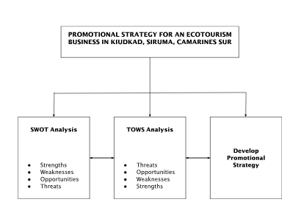
Figure 2. Conceptual Paradigm

Throughout this phase, guiding principles rooted in ecotourism, sustainability objectives, and established strategic marketing frameworks ensure that the proposed strategies were both feasible and closely aligned with the resort’s vision of enriching the visitor experience while safeguarding the natural beauty of Siruma.
The output phase is a targeted promotional strategy tailored to KiudKad’s unique context and informed by the insights generated in the previous phases. It may include initiatives such as social media campaigns emphasizing the resort’s eco-values, curated eco-tour packages that highlight local biodiversity and heritage, partnerships with local communities and NGOs, and refined brand positioning to appeal to conscious travelers. This strategy aims to increase visibility in key markets, attract more visitors, enhance community engagement, and foster sustainable, long-term growth for both the resort and the surrounding area.

METHODS
Research Methods
The study was conducted in several phases to ensure a systematic and comprehensive approach to data collection and analysis.
- Coordination and Permissions
The researcher will first coordinate with the relevant authorities and the management of KiudKad – “The Last Resort” to obtain the necessary permissions and approvals to conduct the study. This will involve formal communication and documentation outlining the purpose of the research, the data collection procedures, and ethical considerations.
Marketing and Promotional Strategy Evaluation Survey (MPSES)
The MPSES will be administered to the selected employees of KiudKad to assess the current marketing and promotional strategies of KiudKad “The Last Resort”. The survey will gather employee insights and experiences related to their awareness of the resort’s current marketing efforts, social media and online presence, promotional channels, marketing challenges and opportunities, and staff involvement and training. Clear explanations to the participants regarding the assessment's purpose and instructions will be provided, allowing them sufficient time to respond and ensuring that all completed forms are collected and kept confidential.

- Unstructured Interview
It will be conducted with the resort owner/administrator. The interview will be conducted in a conversational manner to encourage open-ended discussions, guided by key questions to ensure coverage of relevant topics, and audio recorded with the participant's consent for accurate transcription and analysis with detailed notes taken by the researcher. This qualitative interview will be analyzed to identify perceived strengths, weaknesses, opportunities, and threats related to the resort's promotional efforts.

- SWOT Analysis
Following the collection of data through the Marketing and Promotional Strategy Evaluation Survey and unstructured interview, the data will undergo thematic analysis to identify key patterns and insights. Subsequently, a SWOT (Strengths, Weaknesses, Opportunities, and Threats) analysis will be conducted using the findings from the thematic analysis to provide a structured framework for the development of a targeted promotional strategy for KiudKad – “The Last Resort”.

- TOWS Analysis
Following the completion of the SWOT analysis, a TOWS analysis will be conducted. This will involve using the identified Strengths, Weaknesses, Opportunities, and Threats to formulate strategic options for KiudKad – “The Last Resort”. The TOWS matrix will facilitate the development of strategies that: leverage strengths to maximize opportunities (SO strategies), overcome weaknesses by taking advantage of opportunities (WO strategies), use strengths to mitigate threats (ST strategies), and minimize weaknesses and avoid threats (WT strategies). This comprehensive analysis will further inform the development of a tailored and relevant promotional strategy.

- Statistical Treatment
Descriptive statistics such as frequencies and percentages will be used to analyze the demographic profile of the respondents as presented in Table 1. Qualitative data gathered from the Marketing and Promotional Strategy Evaluation Survey and unstructured interviews will be analyzed using thematic analysis, which focuses on identifying patterns and themes within the textual data.

Respondents Profile
Table 1. Consolidated profile of the respondents
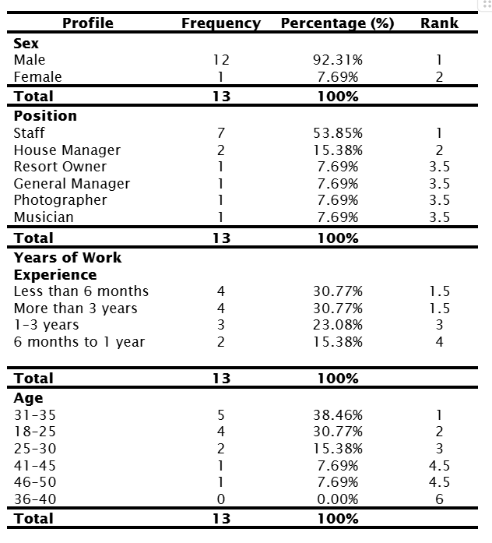

RESULTS & DISCUSSIONS
Table 2
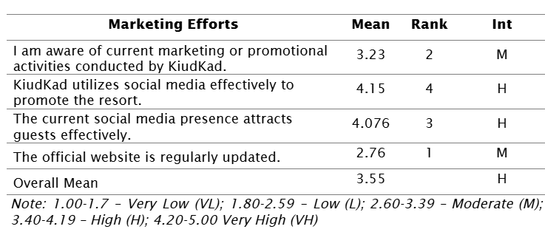
The survey data shows mixed perceptions of KiudKad’s marketing. Awareness of promotions was moderate (Mean = 3.23), while social media effectiveness (Mean = 4.15) and guest attraction (Mean = 4.076) scored high. A weakness was noted with the official website's infrequent updates (Mean = 2.76). Overall, the performance mean was 3.55, indicating strong digital engagement but highlighting a need for better traditional platform maintenance. This suggests gaps in KiudKad’s promotional strategy, especially in online presence.
KiudKad’s strong social media presence aligns with ecotourism marketing trends, utilizing platforms like Instagram and Facebook for visual storytelling (Filieri et al., 2018). However, their low website score indicates a missed opportunity for credibility and direct bookings, as official sites are key information sources (Buhalis & Law, 2008). With moderate awareness, expanding outreach through collaborations with eco-travel influencers or regional tourism fairs could improve visibility. This highlights the need for a balanced strategy leveraging both social media and website channels.
The results indicate that KiudKad’s promotional strategy effectively engages niche audiences on social media but does not fully leverage its digital presence. High social media scores align with the Push-Pull Theory, where appealing content meets travelers’ desires for nature-based experiences. However, the resort's poor website performance risks undermining trust among eco-tourists, who prioritize transparency. This suggests the need for KiudKad to align its messaging across platforms to reinforce its brand as a sustainable destination.
The findings relate to destination image formation and the 7Ps of marketing. While social media shapes KiudKad’s "induced image," the lack of website updates weakens physical evidence, a crucial aspect of the 7Ps. The Global Sustainable Tourism Council highlights digital storytelling for eco-destinations, supporting the need for website improvements. Case studies like Bantayan Island demonstrate that consistent online branding enhances visibility for lesser-known eco-destinations, emphasizing the importance of aligning KiudKad’s promotional strategy with sustainable tourism practices.
To enhance credibility and convenience, KiudKad should revamp its website with real-time updates, sustainability metrics, and seamless booking features. Amplifying social media campaigns through eco-influencers and user-generated content can strengthen its appeal. Implementing the 7Ps framework, by training staff to share guest stories and offering virtual tours of eco-friendly facilities, will further reinforce the brand. Collaborating with regional tourism boards to include KiudKad in Bicol’s promotional materials will expand its reach. These actions create a cohesive strategy that combines digital strengths with sustainable branding to attract more tourists.

Table 3
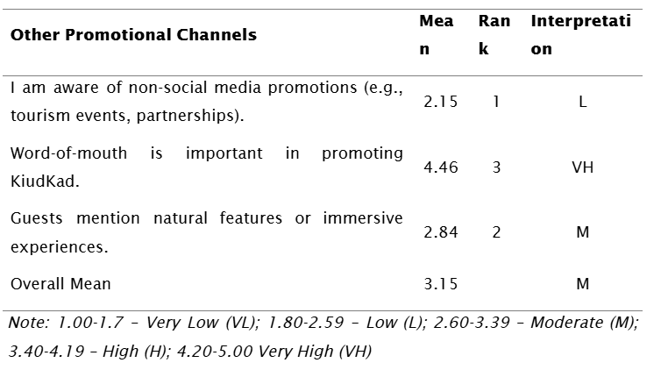

Table 3 illustrates the disparities in KiudKad's non-digital promotional efforts. Word-of-mouth (WOM) received a "Very High" rating (Mean = 4.46), establishing its strong influence in raising awareness. In contrast, non-social media promotions such as events and partnerships were rated "Low" (Mean = 2.15), while mentions of natural features received a "Moderate" score (Mean = 2.84). The overall mean (3.15) indicates a "Moderate" performance, highlighting a reliance on organic WOM but weak offline campaigns.
The data emphasizes the importance of WOM, consistent with ecotourism's dependence on personal recommendations (Lee et al., 2019). However, the low score for organized offline promotions signals missed opportunities in community-based tourism (Hafezi et al., 2023) and regional collaborations. The moderate score for experiential mentions suggests guests appreciate nature immersion but lack avenues to share these experiences widely.
KiudKad's promotional strategy is imbalanced: effective WOM pulls visitors through trusted networks, but the absence of formal offline campaigns limits broader outreach. This is in line with destination image theory (Stylidis et al., 2017), which advocates for diverse channels. While natural features are highlighted in WOM, they need strategic amplification to convert interest into visits.
Insights on sustainable ecotourism practices (e.g., community partnerships) and push-pull theory (Joo et al., 2020) provide context. Successful eco-destinations balance organic WOM with proactive promotions. KiudKad’s inadequate offline efforts contrast with successful models like Suyac Island, showcasing missed chances to highlight unique selling points through structured campaigns.
To enhance its promotion, KiudKad should forge partnerships with local governments, like Siruma's, to co-host eco-tourism events. Implementing a referral program could incentivize guests to share their experiences on platforms like TripAdvisor. Creating branded storytelling content, including testimonials and mini-documentaries, can elevate immersive experiences. Finally, participating in regional tourism fairs can increase visibility among eco-tourists and travel agencies, addressing the current lack of awareness in non-digital promotions.

Table 4
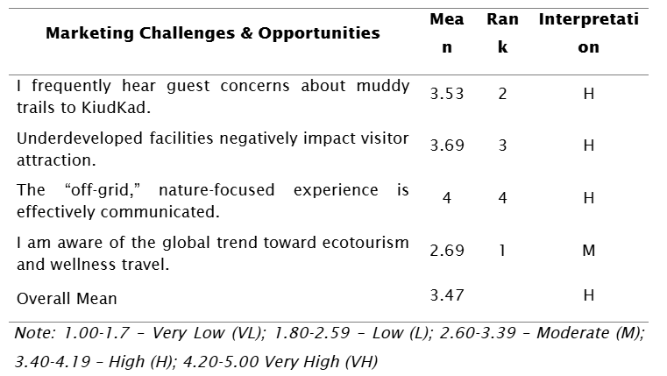

Table 4 highlights important aspects of KiudKad’s operational and marketing landscape. The resort effectively promotes its "off-grid," nature-focused experience (Mean = 4.00), yet faces challenges with muddy trails (Mean = 3.53) and underdeveloped facilities (Mean = 3.69). Awareness of global ecotourism trends is moderate (Mean = 2.69), indicating a need for better market alignment, while the overall mean score (3.47) signifies "High" performance but also points to areas needing improvement.
High scores regarding trails and facilities could hinder visitor satisfaction, affecting repeat business and word-of-mouth referrals. Although the "off-grid" experience appeals to eco-conscious travelers, the moderate trend awareness suggests KiudKad is not fully leveraging the demand for sustainable travel. Infrastructure gaps and market awareness indicate a disconnect between branding and execution, risking its destination image.
To address these issues, KiudKad should enhance its infrastructure sustainably and align its offerings with current wellness trends, such as yoga sessions. Partnerships with local governments could help fund these improvements and promote KiudKad as a sustainable tourism model in Bicol.
Despite moderate formal training scores, staff report high confidence in promoting KiudKad, indicating that experience rather than structured training drives their knowledge. Their enthusiasm for further training suggests a motivated workforce, which could enhance guest interactions but needs formalized training structures to improve consistency. This reflects the importance of staff interactions in shaping visitor perceptions.

Table 5
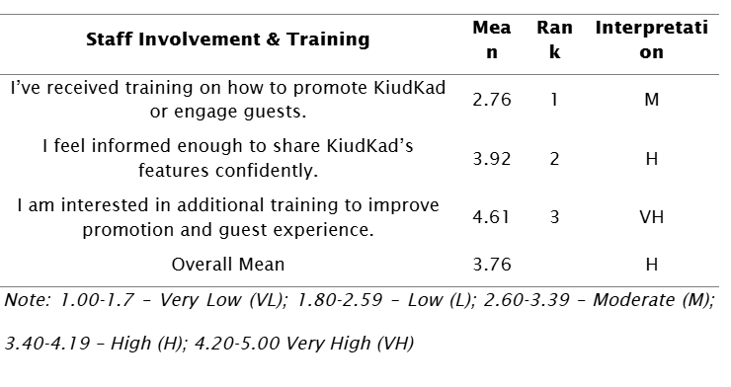
Table 5 highlights staff preparedness and engagement in KiudKad's promotional efforts. While staff feel moderately trained (Mean = 2.76) and are confident in sharing resort features (Mean = 3.92), their strong interest in additional training (Mean = 4.61) is notable. The overall mean of 3.76 indicates solid staff engagement and the need for improved training programs.
Referring to the 7Ps' "People" component and community-based ecotourism models (Hafezi et al., 2023), successful eco-destinations emphasize continuous staff development. The push-pull theory (Joo et al., 2020) suggests that well-trained staff can better convey KiudKad's unique offerings.
KiudKad should implement a structured training program focusing on sustainability, storytelling, and guest engagement. A "Culture Ambassador" initiative can empower confident staff to mentor others. Monthly expert sessions, case studies, and digital training tools will enhance continuous learning, tying these efforts to career development to sustain high motivation.

Table 6
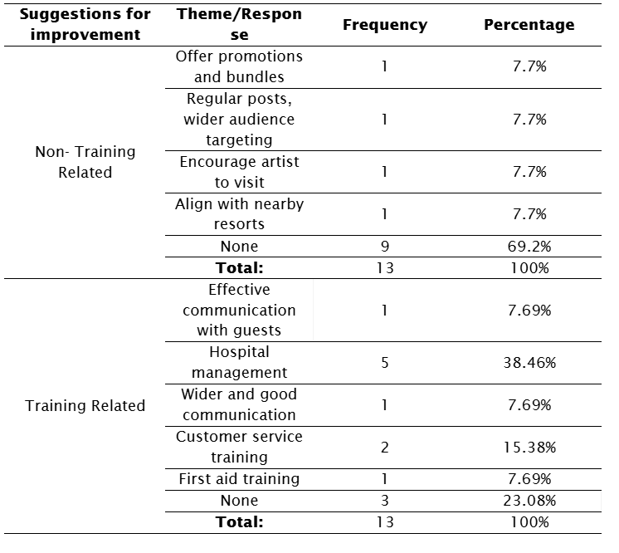
The data highlights two main categories of improvement suggestions from staff. For non-training improvements, 69.2% had no input, while minor suggestions included promotional bundles and collaborations (7.7% each). In contrast, training-related suggestions were more significant, with hospital management training being the top request (38.46%), followed by service quality training (15.38%). This suggests staff prioritize training needs over marketing strategies.
The lack of suggestions for marketing may indicate either satisfaction with current strategies or limited engagement in that area. The focus on training aligns with the 7Ps' "People" and "Process" elements, emphasizing the importance of service delivery in enhancing guest experiences. Findings suggest KiudKad's staff are more focused on improving service than promotional efforts, showing a need for increased involvement in strategic marketing planning.
To address this, KiudKad should prioritize hospitality training in guest relations and crisis management. They could also implement peer sharing sessions to encourage marketing ideas and cross-train front-line staff with the marketing team. Establishing a "continuous improvement" channel for staff suggestions will further enhance operations, ensuring alignment with global ecotourism standards while maintaining local authenticity.

The unstructured interview with the owner of KiudKad “The Last Resort” highlights a strong commitment to authentic branding and social media marketing. Visitors appreciate the resort's natural ambiance, contributing to high customer satisfaction. local empowerment initiatives, no formal tour-guiding programs, limited government support for tourism, minimal food services, and weather-related disruptions.

Table 7
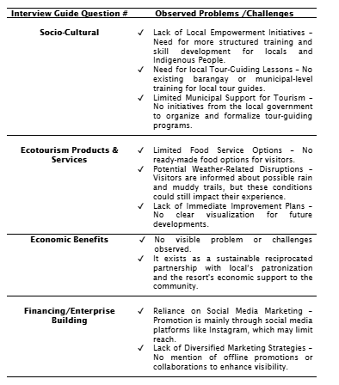

While KiudKad maintains a beneficial partnership with the community and relies heavily on Instagram for promotion, this narrow marketing focus may limit reach. The resort’s operational gaps—like limited food options and the absence of a clear growth strategy—risk undermining long-term sustainability and competitiveness.
Insights from the Review of Related Literature emphasize the need for local training and support in tourism development. To foster sustainable growth, it is recommended that KiudKad diversify its marketing strategies, collaborate with local governments, offer structured training for locals, and explore partnerships with eco-tourism agencies to enhance community-led tourism.

Table 8
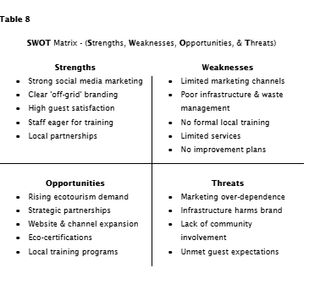
The KiudKad resort has strengths in social media marketing, off-grid branding, staff hospitality, and local partnerships, but faces weaknesses in marketing diversification, infrastructure, and lack of training programs. It has opportunities related to global ecotourism trends, but threats include overdependence on digital marketing and operational gaps.
While the resort excels in branding and social media engagement, weaknesses in infrastructure and limited marketing outreach hinder accessibility and community integration. To improve, KiudKad should diversify its marketing strategy beyond social media, enhance its facilities, and invest in local community training.
The Review of Related Literature supports KiudKad’s alignment with ecotourism principles, but highlights the need for formal empowerment initiatives. Challenges noted in Philippine tourism stress the importance of targeted, community-driven interventions.
For sustainable growth, KiudKad should adopt a broader marketing approach, empower local communities through training, address infrastructure issues, and monitor its environmental impact. Launching a unified marketing campaign can help position the resort effectively in the ecotourism market.

Table 9
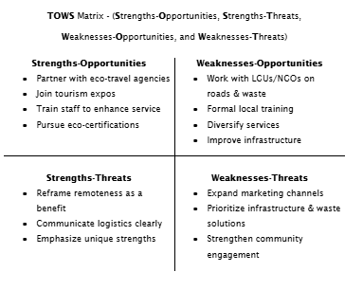
The TOWS analysis for KiudKad highlights how its internal strengths and weaknesses interact with external opportunities and threats to inform strategic actions. SO strategies focus on expanding partnerships and enhancing staff training to leverage the growing ecotourism trend. ST strategies aim to manage guest expectations and strengthen brand communication, addressing its marketing and infrastructure vulnerabilities. WO strategies emphasize community collaboration for infrastructure improvement, while WT strategies focus on brand protection through diversification and local community empowerment.
KiudKad stands at a pivotal point, with the potential to become a leading ecotourism destination if foundational weaknesses are addressed. Long-term success relies on integrating digital innovation, community involvement, and government collaboration to meet the expectations of conscious travelers.
The TOWS strategies align with insights from relevant literature, linking ecotourism initiatives to sustainable practices and community engagement. Recommendations for KiudKad include prioritizing training programs with local agencies, developing infrastructure via grants, and diversifying promotional strategies. Messaging should reframe “remoteness” as a unique and authentic experience, enhancing its appeal while leveraging existing brand recognition.

Steps for an Effective Promotional Strategy
This section analyzes the Marketing and Promotional Strategy Evaluation Survey (MPSES) and interviews with KiudKad employees and the owner/administrator, detailing the resort's marketing strategies, operational challenges, unique assets, and areas for growth.

Input
The input phase involved collecting and analyzing primary and secondary data to evaluate KiudKad – “The Last Resort” within the ecotourism landscape.

Primary Resources:
- MPSES Survey:Conducted with staff, revealing awareness of social media marketing but highlighting challenges such as poor road access, waste management issues, and lack of training. The staff recognized strengths in branding and hospitality.
- Unstructured Interviews: Reinforced the commitment to authentic branding and high customer satisfaction, while identifying challenges like minimal local empowerment and limited services.

Secondary Resources:
Contextual research examined the tourism landscape of Siruma, marketing strategies for ecotourism, and the importance of community engagement, underscoring KiudKad's authentic experiences and local benefits.

Process
A systematic approach using the Input-Process-Output (IPO) model analyzed data to formulate strategies. Key steps included:

SWOT Analysis:
- Strengths: Strong social media marketing, clear branding, high guest satisfaction, and eagerness for staff training.
- Weaknesses: Limited marketing channels, poor infrastructure, and no formal training programs.
- Opportunities: Rising ecotourism demand, strategic partnerships, and local training.
- Threats: Over-dependence on marketing, infrastructure challenges, and unmet guest expectations.

TOWS Analysis:
Developed actionable strategies by matching internal strengths with external opportunities while creating contingency plans for weaknesses and proactive measures for threats. Key strategies included partnering with eco-travel agencies, enhancing staff training, and pursuing eco-certifications.

CONCLUSIONS & RECOMMENDATION
This section presents the findings based on the gathered data, the conclusions derived from the analysis, and the recommendations formulated to help increase tourist visitation at KiudKad – “The Last Resort” of Siruma, Camarines Sur.

This study aimed to develop a targeted promotional strategy to increase tourist visitation at KiudKad – “The Last Resort” of Siruma, Camarines Sur.

The analysis highlights that KiudKad's identity as an authentic, off-grid ecotourism site is a significant strength. To attract eco-conscious travelers, it is crucial to enhance marketing efforts by developing a professional website, improving search engine visibility, and collaborating with online travel platforms. Engaging the community and focusing on sustainability are also essential. However, the resort faces challenges with limited training, amenities, and infrastructure that could threaten its competitiveness. Therefore, its promotional strategy should reach diverse audiences while preserving its authentic character and clearly communicating its value.

It was recommended to the following recommendation:
- Diversify and Enhance Digital Marketing Channels
KiudKad should create a professional, user-friendly, search-optimized website as a central hub for information and bookings. Partnering with online travel agencies, influencers, and niche platforms will expand its reach.
- Craft Compelling Messaging
It clearly communicates KiudKad's identity as "The Last Resort," a haven for off-grid, nature-driven travel, using storytelling and high-quality visuals to showcase experiences and community involvement.
- Implement Targeted Content Marketing
Develop a content calendar with blog posts, videos, and social media campaigns focusing on ecological and cultural richness, covering local traditions, wildlife, sustainability, and visitor testimonials.
- Foster Strategic Partnerships
Collaborate with local government units and ecotourism organizations for co-created campaigns and inclusion in targeted travel packages.
- Develop Experiential Marketing
Engage visitors through virtual tours, tourism expos, and user-generated content, incorporating reviews and testimonials for credibility.

- Empower the Local Community
Formalize staff training with local agencies for quality service and promote community-led initiatives for authentic engagement.

- Address Operational Gaps
Improve infrastructure, such as road access and trail maintenance, and introduce local cuisine while implementing sustainability measures to enhance the visitor experience.

REFERENCES
Adam, F., Hussain, K., Neubert, M. J., Shahid, M. S., & Sohal, A. C. (2016). The influence of service innovation and employees’ competencies on customer satisfaction: Mediating role of service quality. Total Quality Management & Business Excellence, *27*(11-12), 1251–1267.

Allen, A. (2020, October 8). The 7Ps of The Marketing Mix. Oxford College of Marketing. https://blog.oxfordcollegeofmarketing.com/2020/10/08/understanding-the-7ps-of-the-marketing-mix/

Aquino, R., & Porter, B. (2022). Contemporary issues in tourism management in the Philippines. In Contemporary Issues in Tourism Management in the Philippines (pp. 1–14). Springer. https://doi.org/10.1007/978-981-19-4497-0_1

Banaria, D. (2022). Siruma travel Blog. Underrated Adventures. Retrieved from: https://www.underratedadventures.com/post/siruma-camarines-sur-philippines

Barrios, S. (2020). Paraisong Nawala: Exploring sustainable ecotourism in the Philippines [Undergraduate thesis, Scripps College]. Scholarship @ Claremont. https://scholarship.claremont.edu/scripps_theses/1524/

Behsudi, A. (2020). Tourism-dependent economies are among those harmed the most by the pandemic. Finance & Development, *57*(4), 36–39. https://www.imf.org/en/Publications/fandd/issues/2020/12/impact-of-the-pandemic-on-tourismbehsudi

Beltran, R. (2023, May 10). Sagay mangrove eco-tourism project uplifts lives. Visayan Daily Star. https://visayandailystar.com/sagay-mangrove-eco-tourism-project-uplifts-lives/

Biclar, L. A. B., Linan, E. L., Madiclum, R. B., & Olapane, R. F. (2023). Sustainable ecotourism: The case of the riverine communities in Capiz, Philippines. Sustainable Energy and Environment Review, *1*(1), 40–49. https://doi.org/10.59762/seer924712041120231103143411

Billion Bricks. (2023). Bantayan Island: Successfully promoting sustainable eco tourism in the Philippines. https://billionbricks.org/blog/bantayan-island-successfully-promoting-sustainable-tourism-in-the-philippines/

Buhalis, D., & Law, R. (2008). Progress in information technology and tourism management: 20 years on and 10 years after the Internet—The state of eTourism research. Tourism Management, *29*(4), 609–623. https://doi.org/10.1016/j.tourman.2008.01.005

Buslon-Sia, V., Ferrater-Gimena, J., Etcuban, J., & Tan, A. (2019). Ecotourism as a catalyst of poverty alleviation in rural economy in Cebu, Philippines. Asian Review of Social Sciences, *8*(3), 1–7. https://doi.org/10.51983/arss-2019.8.3.1605

Cambridge University Press & Assessment. (2024). Ecotourism. In Cambridge Dictionary. Retrieved from https://dictionary.cambridge.org/us/dictionary/english/ecotourism

Chan, J. K. L., & Baum, T. (2007). Motivation factors of ecotourists in ecolodge accommodation: The push and pull factors. Asia Pacific Journal of Tourism Research, *12*(4), 349–364. https://doi.org/10.1080/10941660701761035

CIPD. (2025, March 7). SWOT analysis: Factsheet. https://www.cipd.org/en/knowledge/factsheets/swot-analysis-factsheet/

Collins. (2024). Management regulations. In Collins English Dictionary. Retrieved from https://www.collinsdictionary.com/dictionary/english/management-regulations

Department of Tourism. (2024). First ever modified eco-friendly tourist rest area to rise in Bicol region. Republic of the Philippines. Retrieved from https://beta.tourism.gov.ph/news_and_updates/first-ever-modified-eco-friendly-tourist-rest-area-to-rise-in-bicol-region/

Destinations and Tea. (2023, October 1). Kiudkad—The Last Resort: A secluded paradise in Bicol. https://www.destinationsandtea.com/2023/10/01/kiudkad-the-last-resort-a-secluded-paradise-in-bicol/

Dias, Á., Viana, J., & Pereira, L. (2024). Barriers and policies affecting the implementation of sustainable tourism: The Portuguese experience. Journal of Policy Research in Tourism, Leisure and Events, *16*(5), 1–19. https://doi.org/10.1080/19407963.2024.2314514

Eco Explorations. (2024). Bicol. Retrieved from https://ecoexplorationsph.com/bicol/

Fatih, A. (2022). Sayı 3, 2022 of Social Sciences, Tourism Management Department. International Journal of Management Economics and Business, *18*(3), 856–874. https://doi.org/10.17130/ijmeb.1002537

Fereshteh Hafezi, Masoud Bijani, Saeed Gholamrezai, Moslem Savari, Sabine Panzer-Krause (2023). Towards sustainable community-based ecotourism: A qualitative content analysis, Science of The Total Environment, *891*, 164411. https://doi.org/10.1016/j.scitotenv.2023.164411

Filieri, R., Alguezaui, S., & McLeay, F. (2018). Why do travellers trust online travel reviews? The role of source credibility and expertise. Journal of Travel Research, *57*(5), 636-648.

Gardner, B., & Levy, S. (2008). Destination image. In Destination Marketing: An Integrated Marketing Communication Approach (pp. 211-230). NSC Poltek Sby.

Global Sustainable Tourism Council. (2024, October 10). The difference between ecotourism and sustainable tourism. https://www.gstc.org/ecotourism/

GOV.PH. (2023). Siruma LGU profile. Municipality of Siruma. Retrieved from https://siruma.ph/lgu-profile/

Hunter, D., Mccallum, J., & Howes, D. (2019). Defining exploratory-descriptive qualitative (EDQ) research and considering its application to healthcare [Preprint]. University of Glasgow. https://eprints.gla.ac.uk/180272/

International Labour Organization. (2021, November 18). *COVID-19 and employment in the tourism sector in the Asia–Pacific region*. https://www.ilo.org/resource/brief/covid-19-and-employment-tourism-sector-asia%E2%80%93pacific-region

Jabal, R. (2024, March 1). The imperatives of sustainable tourism in the Philippines. BusinessWorld Online. https://www.bworldonline.com/opinion/2024/03/01/578656/the-imperatives-of-sustainable-tourism-in-the-philippines/

Joo, D., Lee, C. K., & Lee, S. J. (2020). Examining the push and pull factors of rural tourism: A case study of agricultural tourism in South Korea. Sustainability, *12*(2), 585. https://doi.org/10.3390/su12020585

Kalonda, H. (2023). Impact of COVID-19 on Philippines Tourism Industry: Macroeconomic and Microeconomic Implications. Journal of Economics, Finance and Accounting Studies, *5*(3), 17–21. https://doi.org/10.32996/jefas.2023.5.3.2

KiudKad - The Last Resort. (2024, May 29). Camping in Siruma, Camarines sur. Campsites Philippines. https://campsites.ph/campsite/kiudkad-the-last-resort/129

Lanndon Ocampo, Junine Angela Ebisa, Jefferson Ombe, Meredith Geen Escoto (2018). Sustainable ecotourism indicators with fuzzy Delphi method – A Philippine perspective, Ecological Indicators, *93*, 874-888. https://doi.org/10.1016/j.ecolind.2018.05.060

Law, R., Leung, R. & Wong, J. Y. (2015). Service quality and the training of employees: The mediating role of organizational commitment. Tourism Management, *46*, 419–430. https://doi.org/10.1016/j.tourman.2014.08.001

Lee, T. H., Jan, F. H., & Hsieh, C. M. (2019). Ecotourists’ motivation and willingness to pay for conservation: The case of the Houwan Mangrove Protected Area in Taiwan. Sustainability, *11*(3), 714. https://doi.org/10.3390/su11030714

MarineBio Conservation Society. (2024). Sustainable ecotourism. https://www.marinebio.org/conservation/sustainable-ecotourism/

Marine-Roig, E., & Ferrer, B. (2018). How does destination image influence online booking intentions? The moderating role of trust. Tourism Management, *66*, 336-347.

Naeem, M., Ozuem, W., Howell, K. E., & Ranfagni, S. (2023). A step-by-step process of thematic analysis to develop a conceptual model in qualitative research. International Journal of Qualitative Methods, *22*(1), 1–18. https://doi.org/10.1177/16094069231205789

Nicolas, A., Hidalgo, H., Fresnido, M. B., Mangku, I. G. P., & Udayana, I. G. B. (2022). Melitourism potential of Bali, Indonesia and Bicol, Philippines. Asia Pacific Journal of Sustainable Agriculture, Food and Energy, *10*(1), 8–14. https://doi.org/10.36782/apjsafe.v10i1.137

Painoli, A. (2019). Challenges faced by the tourism sector in Uttarakhand. International Journal of Management, Technology and Engineering, *9*(5), 2249–7455.

Panay News. (2023, August 28). Redefining the resort experience: The power of satellite internet connectivity in remote areas. https://www.panaynews.net/redefining-the-resort-experience-the-power-of-satellite-internet-connectivity-in-remote-areas/

Patrick Brandful Cobbinah (2015). Contextualizing the meaning of ecotourism, Tourism Management Perspectives, *16*, 179-189. https://doi.org/10.1016/j.tmp.2015.07.015

Pertiwi, V., & Nuari Harmawan, B. (2022). Tourism management issues and its relationship with the sustainable development goals. Jurnal Borneo Administrator, *18*(1), 51–64. https://doi.org/10.24258/jba.v18i1.997

Philippine Department of Tourism. (2024). Bicol. Philippine Department of Tourism London. https://itsmorefuninthephilippines.co.uk/wp-content/uploads/PDOTL_Bicol_Web.pdf

Philippine News Agency. (2021, May 28). Department of Tourism launches 5 year development plan for tourism professionals. https://www.pna.gov.ph/index.php/articles/1142567

Power Traveller. (2024). KiudKad Siruma: The Last Resort. https://powertraveller.com/kiudkad-siruma-the-last-resort/

Prayag, G., Hosany, S., Muskat, B., & Chiappa, G. D. (2019). Understanding the relationships between tourists' emotional experiences, perceived value, satisfaction, and behavioral intentions. Journal of Travel Research, *58*(1), 41-54.

Rappler. (2023, July 28). At Kiudkad – The Last Resort, visitors can be part of a relaxed, off-grid community. https://www.rappler.com/life-and-style/travel/kiudkad-the-last-resort-siruma-camarines-sur-community-getaway/

Rebuya, N. R., & Meñez, M. F. L. (2024). Resource conservation strategies, visitor experience, and satisfaction at natural parks in Bicol Region, Philippines. OALib, *11*(07), 1–36. https://doi.org/10.4236/oalib.1111863

Ribeiro, M. A., Pinto, P., & Silva, J. A. (2019). Residents’ perceptions of tourism impacts and sustainable tourism development: A cluster analysis approach. Sustainability, *11*(3), 695. https://doi.org/10.3390/su11030695

Rosel, T. (2025, March 21). Tourism a key contributor to national economy, driving force for development – Frasco. Manila Bulletin. https://mb.com.ph/21/3/2025/tourism-key-contributor-to-national-economy

Scheyvens, R. (1999). Ecotourism and the empowerment of local communities. Tourism Management, *20*(2), 245–249. https://doi.org/10.1016/S0261-5177(98)00069-7

Stylidis, D., Shani, A., & Belhassen, Y. (2017). Testing an integrated destination image model across different tourism segments. Tourism Management, *58*, 184–199. https://doi.org/10.1016/j.tourman.2016.10.005

SunStar. (2023, August 16). Revolutionizing the resort experience: The power of satellite internet connectivity in remote areas. https://www.sunstar.com.ph/cebu/business/revolutionizing-the-resort-experience-the-power-of-satellite-internet-connectivity-in-remote-areas

Sybing, R. (2024). Unstructured interviews: When and how to use them. ATLAS.ti. https://atlasti.com/research-hub/unstructured-interviews

Tadeo, J., & Mendoza, X. (2024). Regional-based tourism analysis: The case of Cavite Province, Philippines. Journal of Business on Hospitality and Tourism, *10*(1), 270–282. https://doi.org/10.22334/jbhost.v10i1.490

Tan, K. S. (2022, June 2). KiudKad In Camarines Sur: Vacation homes at an off-grid location. TheSmartLocal Philippines. https://thesmartlocal.ph/kiudkad/

The International Ecotourism Society. (2015). What is ecotourism? https://ecotourism.org/what-is-ecotourism/

Trymata. (2023, December 20). What is a case study? Definition, research methods, sampling and examples. https://trymata.com/blog/what-is-a-case-study/

Tussyadiah, I. P., & Fesenmaier, D. R. (2017). Digital transformation in tourism: Opportunities and challenges. Journal of Travel Research, *56*(7), 795-806.

United Nations World Tourism Organization. (2023). Tourism’s importance for growth highlighted in World Economic Outlook report. https://www.unwto.org/news/tourism-s-importance-for-growth-highlighted-in-world-economic-outlook-report

University of Hertfordshire. (2022). An introduction to the TOWS analysis. https://www.herts.ac.uk/__data/assets/pdf_file/0007/290482/An-introduction-to-the-TOWS-analysis.pdf

Visit CamSur. (2025). Explore the wonders of Camarines Sur. https://visitcamsur.com/places-to-go/beaches

Walton, J. K. (2023). Tourism. In Encyclopedia Britannica. https://www.britannica.com/topic/tourism

Yin Zhang, Bin Deng (2024). Exploring the nexus of smart technologies and sustainable ecotourism: A systematic review, Heliyon, *10*(11), e31996. https://doi.org/10.1016/j.heliyon.2024.e31996

Yun Eui Choi, Chi-Ok Oh, Jinhyung Chon (2020). Applying the resilience principles for sustainable ecotourism development: A case study of the Nakdong Estuary, South Korea, Tourism Management, *83*, 104237. https://doi.org/10.1016/j.tourman.2020.104237

Zuo, W., Udomwong, P., Fu, J., & Onpium, P. (2023). Destination image: A review from 2012 to 2023. Cogent Social Sciences, *9*(1). https://doi.org/10.1080/23311886.2023.2240569

